An New INS/VNS Integrated Navigation Model for Planetary Rovers
Yongzhi Xu^{1, a}, Xiaolin Ning^{1, b}
¹ School of Instrument Science & Opto-electronics engineering, Beihang University
ªbuaaxyz@yeah.net, ^{b}ningxiaolin@buaa.edu.cn,
Keywords: Inertial navigation; vision navigation; INS/VNS integrated navigation; planter rovers.
Abstract. Inertial and vision integrated navigation (INS/VNS) is an important autonomous navigation method for planetary rovers. Traditional INS/VNS methods build state model based on the inertial error model, which consider the errors of vision system as random. However, the binocular cameras calibration errors will bring some constant errors to the vision system by the reconstruction process. A new INS/VNS model that adds the constant vision relative motion errors in the state is presented. The simulation results demonstrate that the presented model effectively improves the position and attitude accuracy compared with traditional methods.
Introduction
Inertial navigation and vision navigation are usually used for planetary rovers autonomous navigation, such as in China’s first lunar rover, Yutu , on the Moon, and NASA’s Spirit, Opportunity and Curiosity rovers on Mars. As a consequence of the complementary characteristics of INS and VNS , INS/VNS integrated navigation has become a good choice for planetary rovers. However, traditional INS/VNS methods commonly build state model based on the inertial error model and measurement model based on the vision relative motion. The traditional measurement model considers the vision relative motion errors as random and ignores the constant error . However, the vision relative motion errors are mainly generated from the feature points match errors and errors of the binocular cameras calibration parameters. Because the errors of binocular cameras calibration parameters are constant, so the vision relative motion errors will contain constant errors as well. A new INS/VNS model that adds the constant vision relative motion errors in the state is presented.
Reference Frames
The reference coordinate frames are all defined as right hand frames, including the inertial frame(i,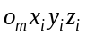), the moon fixed frame(m,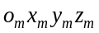), the geographic frame(t,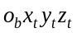), the world frame(w,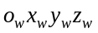), the body frame(b,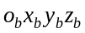) and the camera frame(c,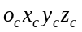), some of which are show in . In t-frame, the x-axis points to the east and the y-axis points to the north. The w-frame is defined as the first instant t-frame. In b-frame, the x-axis points to the right of the rover and the y-axis points to the front of the rover. The origin of c-frame is at the left camera, its x-axis points to the right of the camera and its y-axis points downward.
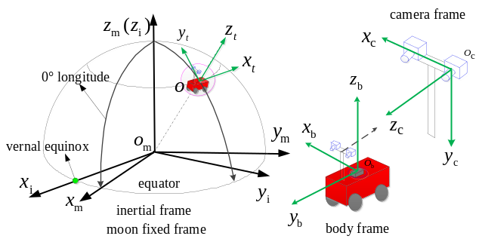
Fig 1 Coordinate frames
State Model
Vision relative motion error model. The procedure of vision navigation system mainly includes feature extraction, feature tracking, stereo matching, 3D reconstruction and motion estimation. By 3D reconstruction, the coordinates of feature points in c-frame are 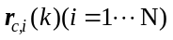, where 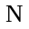 is the number of feature points. 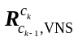 and 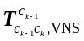 are the vision relative motion parameters in c-frame, which can be calculated as follows:
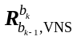 and 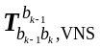 are the corresponding vision relative motion parameters in b-frame, which can be calculated as follows:
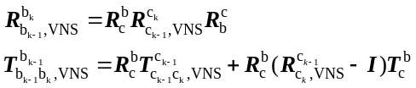
where 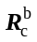 and 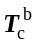 are the rotation matrix and translation vector from c-frame to b-frame. and can be expressed as:
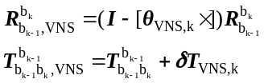
where 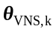 is the error of , 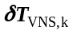 is the error of , and 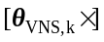 is the cross matrix of .
and are generated from the errors of 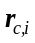, calibration parameters, and . Because the errors of calibration parameters and are constant, so and also contain constant part, which can be defined as follows:
where and 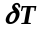 are the constant part of and respectively.
Inertial and vision combined state model. The state model is composed of the inertial and vision error models, and the state is defined as:
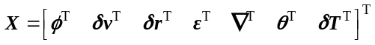
where is the attitude error angles, 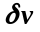 is the velocity error, 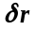 is the position error, is the gyroscopes drift, and is the accelerometers bias. Based on the inertial error model, the state model can be written as:
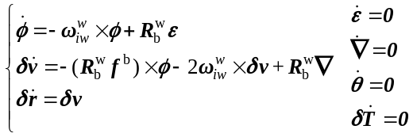
Measurement Model
Relative motion errors measurement. The inertial relative motion parameters are 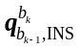 and 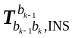, which can be computed as follows:
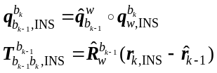
where 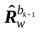and 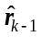 are INS/VNS estimated attitude matrix and position vector at the time instant 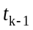 respectively. 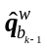 is the quaternion of . 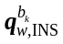 and 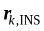 are inertial calculated attitude quaternion and position at respectively.
The difference of relative motion parameters between the inertial and the vision are used as measurement, which can be expressed as:
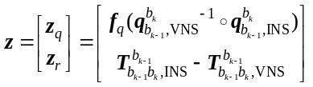
where 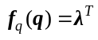 when 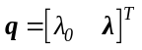.
Relative motion errors measurement model. The quaternion of and can be written as follows:
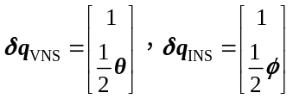
The error expression of can be described as:
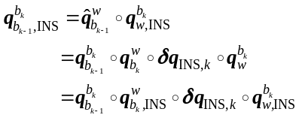
The error expression of 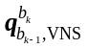 can be described as:
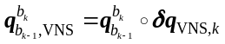
Based on the relative rotation error analysis of inertial and vision, the measurement model of 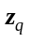can be expressed as:
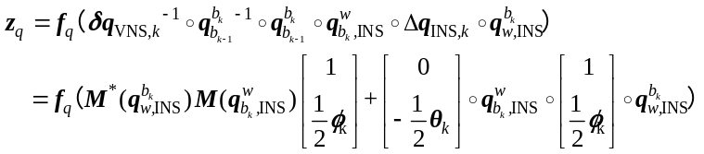
where function 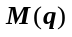 and 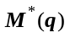 are defined as:
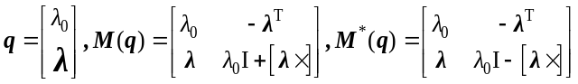
The error expression of can be described as:
The measurement model of can be expressed as:
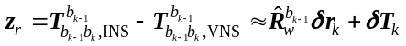
In summary, the measurement model is:
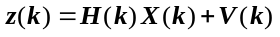
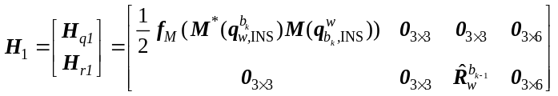
where, function 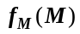 is defined as:
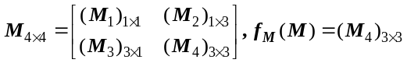
Simulation
Due to limitations in experimental conditions and cost, experiments on the Moon can hardly be achieved. The IMU data and images are produced by a simulation system in this paper. The IMU data is produced by an inertial path generator and the images are produced by a 3DS MAX scene. The 3DS MAX scene is built based on images of the lunar surface from NASA to simulate the real lunar surface.
Simulation conditions. The constant bias and random drift of gyroscopes are 1°/h and 0.5°/h, respectively. The constant bias and random drift of the accelerometers are 100µg and 50µg, respectively. The simulated binocular visual system is a pair of parallel installed cameras with a baseline of 20cm and a height of 1.7m from the surface. The image resolution is 1392×1040 pixels, and the field of view is 45.76º×35.00º. The frequencies of INS and VNS are 100HZ and 0.2HZ respectively. Fig 2 shows a pair of the typical images taken by the binocular cameras.
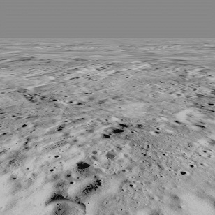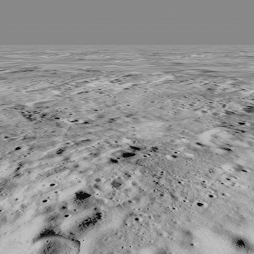
(b) left image (c) right image
Fig 2 Typical simulated images
Simulation results. In the simulation, four types of navigation methods are compared, including the INS, the VNS, the new INS/VNS method presented in this paper(INT1), and the traditional INS/VNS method (INT1) in .
The simulation results are shown in Fig 3- Fig 6 and Table 1. Fig 3 shows the trajectories comparison of VNS, INT1 and INT2. The INS trajectory deviates too much and not shown in Fig 3. It can be seen from Fig 3, the INT2 trajectory is better than NVS, but also significantly deviates. However, the INT1 trajectory is quite close to the ideal trajectory all along the trace, which is much better than INT2. Fig 4, Fig 5 and Fig 6 illustrates attitude errors of the four navigation methods in pitch, roll and yaw respectively. It can be seen that the two INS/VNS integrated methods achieve higher attitude accuracies than INS and VNS. Fig 4 and Fig 5 shows that the pitch and roll errors of INT1 are smaller and smoother than INT2. Fig 6 shows that the yaw errors of INS,VNS and INT2 all diverge heavily with time, but the INT1 head error is relatively convergent.
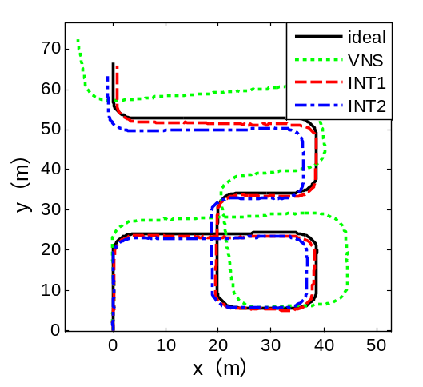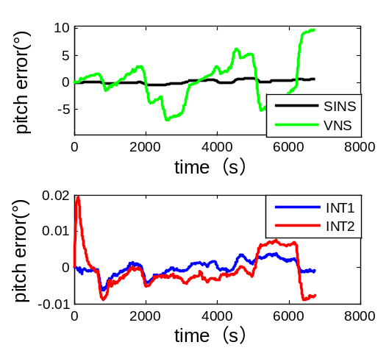
Fig 3 Simulation trajectories Fig 4 Pitch errors
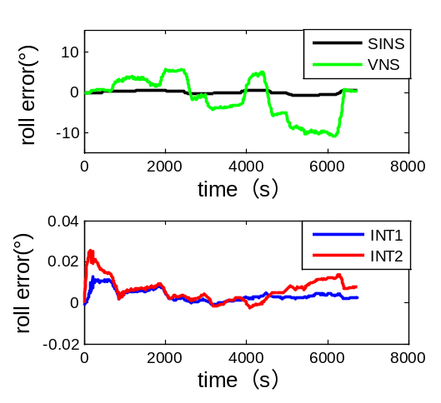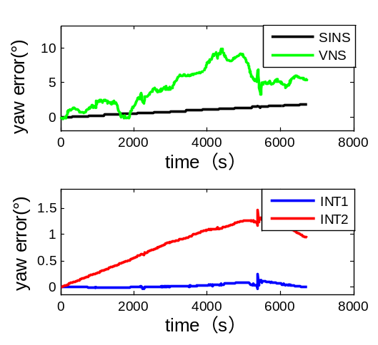
Fig 5 Roll errors Fig 6 Head errors
Table 1 shows the max position and attitude errors of the four navigation methods. The max position error of INT1 is 1.05 m, which is 0.52% of the whole trajectory length 204.17m. The max position error of INT2 is 3.71 m, which is 1.82% of the whole trajectory. The position accuracy of INT1 has decreased to 28.6% of that of INT2. INT1 achieves higher attitude accuracies than INT1, especially in the yaw direction. The yaw error of INT1 is 0.2156°, which has decreased to 17.5% of INT2’s 1.461°. As the position accuracy of vision system is sensitive to the yaw accuracy , the obvious increase of yaw accuracy in INT1 is beneficial. Summary, their is a significant improvement in both position and attitude performance of INT1 compared with INS, VNS and INT2.
Table 1. Max position and attitude errors in the simulations
Methods | Max position error |  |  | Max attitude error/(°)
Methods | absolute  value(m) | percentage  (%) | pitch |  | roll |  | yaw
INS | 25508.54 | 1249.38 | 0.797 |  | -0.788 | 1.878
VNS | 8.72 | 4.27 | 9.695 |  | -10.735 | 9.815
INT1 | 1.05 | 0.52 | -0.006 |  | 0.012 | 0.256
INT2 | 3.71 | 1.82 | 0.019 |  | 0.026 | 1.461
Conclusion
The traditional INS/VNS integrated navigation models for planetary rovers usually ignore the constant errors of vision system. In this paper, the constant errors of vision system are simplified to the relative motion constant error. A new INS/VNS model that adds the state of vision relative motion constant error is presented in this paper. In the simulation, the position accuracy of the new INS/VNS integrated navigation model is 0.52%, which has improved to 28.6% of the traditional model’s 1.82%. The attitude accuracies of the new INS/VNS model are all improved, especially the yaw accuracy, which is 0.256° and improved to 17.5% of the traditional model’s 1.461°. The simulation demonstrates that the new measurement model is effective in providing highly accurate autonomous navigation for planetary rovers.
References
[1] Liu Chuankai, Wang Baofeng, Wang Jia, et al．Integrated INSand vision based orientation determination and positioning of CE 3 lunar rover[J]．Journal of Spacecraft TT&C Technology，2014，33(3)：250-257.
[2] Maimone M, Cheng Y, Matthies L. Two years of visual odometry on the mars exploration rovers [J]. Journal of Field Robotics, 2007, 24(3): 169-186.
[3] Titterton D H, Weston J L. Strapdown Inertial Navigation Technology (2nd Edition) [M]. UK: Institution of Engineering and Technology, 2004.
[4] Hern´, Badino, Kanade T. A Head-Wearable Short-Baseline Stereo System for the Simultaneous Estimation of Structure and Motion; proceedings of the 12th IAPR Conference on Machine Vision Applications, Nara, Japan, F, 2011 [C].
[5] Li M, Mourikis A I. Optimization-based estimator design for vision-aided inertial navigation [J]. Robotics, 2013, 241-248.
[6] Trawny N, Mourikis A I, Roumeliotis S I, et al. Vision‐aided inertial navigation for pin‐point landing using observations of mapped landmarks [J]. Journal of Field Robotics, 2007, 24(5): 357-378.
[7] Roumeliotis S I, Johnson A E, Montgomery J F. Augmenting Inertial Navigation with Image-Based Motion Estimation [M]. International Conference on Robotics and Automation. 2002: 4326-4333.
[8] Fang Q, Huang S X. UKF for Integrated Vision and Inertial Sensors Based on Three-View Geometry [J]. Sensors Journal, IEEE, 2013, 13(7): 2711-2719.
[9] Di Corato F, Innocenti M, Pollini L. An Entropy-Like Approach to Vision-Aided Inertial Navigation; proceedings of the Proc of 18th IFAC World Congress, F, 2011 [C]. Milano (Italy)
[10] Mourikis A I, Trawny N, Roumeliotis S I, et al. Vision-Aided Inertial Navigation for Spacecraft Entry, Descent, and Landing [J]. IEEE Transactions on Robotics, 2009, 25(2): 264-280.
[11] Olson C F, Matthies L H, Schoppers M, et al. Rover navigation using stereo ego-motion [J]. Robotics and Autonomous Systems, 2003, 43(4): 215-229.

